DB Relations
The system as built on branch mini-erp (Version 2.0): the base tables first, then what Purchase, QT 2.0 and User 2.0 added or changed. Sources (Purchase Logic Draft2, QT Upgrade 2.0, User Version 2.0).

Current version summary (as built)
23 tables in 5 groups. Parts 1 and 2 below give every key and rule; this is the short form.
Group | Tables | Main relations
Users and files | User, Attachment | Attachment.uploaded_by -> User. Attachment points to its owner (PurchaseOrder, QtReference or ProductionOrder) by owner_type + owner_id, with no database key
Master data | Customer, Product, Material, MaterialLot, ProductBom, Supplier, SupplierMaterial | Product -> ProductBom -> Material (a BOM line). Material -> MaterialLot (stock by lot). Supplier -> SupplierMaterial -> Material (what a supplier sells, with its price)
Sale | QtReference, QtLine, ProductionOrder, OrderLine, OrderProcess, ProgressEntry | Customer -> QtReference -> QtLine -> Product. Confirm QT makes one ProductionOrder (QtReference.production_order_id, one to one). Order -> OrderLine -> OrderProcess -> ProgressEntry (by User)
Accounting | Invoice, InvoiceLine, Payment, Receipt | One Invoice per ProductionOrder; one Payment and one Receipt per Invoice
Purchase and stock | PurchaseOrder, PurchaseOrderLine, PurchasePayment, StockChange | Supplier -> PurchaseOrder -> PurchaseOrderLine -> Material. One PurchasePayment per PO. StockChange (material, user, and optionally the order or the PO) is the history of every lot change

Rules to remember:
- Delete: children go with their parent (lines, processes, BOM, lots, supplier items, attachments). Anything else that is referenced answers 409 IN_USE. Only a Draft QT or Draft PO can be deleted. Invoices, receipts and stock history are never deleted.
- One to one: Invoice per order, Payment and Receipt per invoice, PurchasePayment per PO, ProductionOrder per confirmed QT.
- Unique: User.email, and the codes and numbers of Product, Material, Supplier, QT, order, invoice, receipt and PO; (material, lot number); (supplier, material); (QT, product).
- Status: QT Draft -> Confirmed. Order Draft -> In Progress -> Completed (computed). Invoice Unpaid -> Paid. PO Draft -> Sent -> Received.
- Stock moves only in StockChange + MaterialLot: Start production deducts the BOM (oldest lot first), Receive PO adds once, and a person can Add, Deduct or Adjust a lot by hand.

Part 1: The base tables (the Mini ERP before Version 2.0)
Table-by-table list of keys, relations and delete rules. The whole model, as built, is in the ER Diagram. The rows of QtReference, Material and User are changed by Part 2 below. Source: docs/api (master-data.md, stock.md, qt.md, orders.md, invoices.md, receipts.md).

Foreign keys
Table | Column | References | Cardinality | Delete rule
QtReference | customer_id | Customer.id | many to one | customer in use -> 409 IN_USE
ProductionOrder | qt_id | QtReference.id | many to one | QT used by an order -> 409 IN_USE
ProductionOrder | customer_id | Customer.id | many to one | customer in use -> 409 IN_USE
OrderLine | order_id | ProductionOrder.id | many to one | goes with the order
OrderLine | product_id | Product.id | many to one | product in use -> 409 IN_USE
OrderProcess | line_id | OrderLine.id | many to one | goes with the line
ProgressEntry | process_id | OrderProcess.id | many to one | never deleted
ProgressEntry | user_id | User.id | many to one | user with history -> 409 IN_USE
ProductBom | product_id | Product.id | many to one | goes with the product
ProductBom | material_id | Material.id | many to one | material in a BOM -> 409 IN_USE
MaterialLot | material_id | Material.id | many to one | goes with the material
StockChange | material_id | Material.id | many to one | material with a non-initial change cannot be deleted
StockChange | order_id | ProductionOrder.id | many to one, optional | set when the start of an order deducts stock
StockChange | user_id | User.id | many to one | never deleted
Invoice | order_id | ProductionOrder.id | one to one | one invoice per order
InvoiceLine | invoice_id | Invoice.id | many to one | goes with the invoice
Payment | invoice_id | Invoice.id | one to one | one full payment per invoice
Receipt | invoice_id | Invoice.id | one to one | one receipt per invoice

Unique keys
Table | Unique
User | email (lower-cased)
Product | code
Material | code
MaterialLot | (material_id, lot_number)
QtReference | qt_number
ProductionOrder | order_number (ORD-yyyy-0001, given by the server)
Invoice | invoice_number, order_id
Payment | invoice_id
Receipt | receipt_number, invoice_id

Lifecycle rules that touch several tables
Event | Tables written | Rule
Start production (POST /orders/:id/start) | ProductionOrder.started_at, MaterialLot, StockChange | Deducts the BOM of every line, oldest lot first. 409 STOCK_SHORT if a material is short. Locks products and processes
Progress entry | ProgressEntry, OrderProcess | Updates the status and completed quantity of the process. An order is Completed when all processes are
Issue invoice | Invoice, InvoiceLine | Only for a Completed order, once. Copies the data (snapshot). Locks the progress of the order
Pay invoice | Payment, Invoice.status, Receipt | Payment date and amount must equal the total (MUST_EQUAL_TOTAL). Sets Paid and issues one receipt
Manual stock change | MaterialLot, StockChange | Add, Deduct or Adjust a lot at any time. The history is never changed or deleted

Chain of one sale
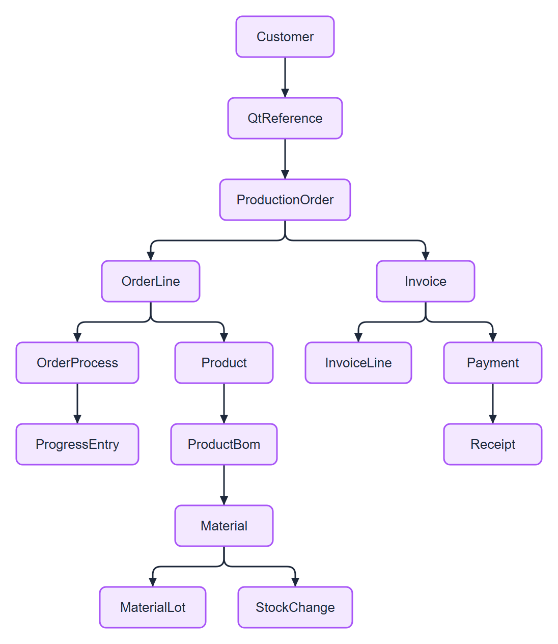
Figure 1. Chain of one sale

Part 2: Added or changed in Version 2.0 (as built)
Keys, relations and rules after the Purchase, QT 2.0 and User 2.0 changes. Only the new or changed rows are listed; everything else stays as in Part 1. The order status is Draft, In Progress, Completed (computed; Draft replaces New). An order is made only by Confirm QT.

New foreign keys
Table | Column | References | Cardinality | Delete rule
SupplierMaterial | supplier_id | Supplier.id | many to one | goes with the supplier
SupplierMaterial | material_id | Material.id | many to one | material sold by a supplier -> 409 IN_USE
PurchaseOrder | supplier_id | Supplier.id | many to one | supplier with a PO -> 409 IN_USE
PurchaseOrder | created_by | User.id | many to one | user with history -> 409 IN_USE
PurchaseOrderLine | po_id | PurchaseOrder.id | many to one | goes with the PO; only a Draft PO can be deleted
PurchaseOrderLine | material_id | Material.id | many to one | material on a PO -> 409 IN_USE
PurchasePayment | po_id | PurchaseOrder.id | one to one | one payment per PO
StockChange | purchase_order_id | PurchaseOrder.id | many to one, optional | set when a PO is received
QtLine | qt_id | QtReference.id | many to one | goes with the QT; only a Draft QT can be deleted
QtLine | product_id | Product.id | many to one | product on a QT -> 409 IN_USE
QtReference | production_order_id | ProductionOrder.id | one to one, optional | set when the QT is confirmed
Attachment | uploaded_by | User.id | many to one | never deleted
Attachment | (owner_type, owner_id) | PurchaseOrder, QtReference or ProductionOrder | many to one, no database key | goes with the owner (service deletes the file too)

Changed columns
Table | Change
QtReference | adds status (Draft, Confirmed), customer_po_number, customer_po_date, production_order_id; drops file_name, file_type, file_path (moved to Attachment)
Material | adds unit
User | rule: role = Worker needs department in (Sales, Factory)

Unique keys
Table | Unique
Supplier | code
SupplierMaterial | (supplier_id, material_id)
PurchaseOrder | po_number
PurchasePayment | po_id
QtReference | qt_number, production_order_id
QtLine | (qt_id, product_id)

Lifecycle rules that touch several tables
Event | Tables written | Rule
Create PO | PurchaseOrder, PurchaseOrderLine | Status Draft. Only materials of the chosen supplier (SupplierMaterial) can be picked. Unit price starts from SupplierMaterial.unit_price, the user can change it. total = sum of line amounts
Edit PO | PurchaseOrderLine | Lines change only in Draft
Change PO status | PurchaseOrder | Draft -> Sent -> Received, one step forward, by hand
Receive PO | PurchaseOrder.received_at, MaterialLot, StockChange | Adds each line to a lot as a stock change Add linked by purchase_order_id. Once only: a second Received does not add again
Pay PO | PurchasePayment | Needs status Received. One payment per PO
Upload file | Attachment | Kinds PO_FILE, QUOTATION, EVIDENCE, OTHER. PDF, PNG or JPG, up to 10 MB. A new PO_FILE replaces the old one
Confirm QT | QtReference.status, ProductionOrder, OrderLine, QtReference.production_order_id | Needs a customer and at least one line. Creates one Draft Factory Order from the QT lines. Once only. The customer PO file is attached to the order. Locks the QT lines
Start production | as before | Unchanged

Chain of the new flows
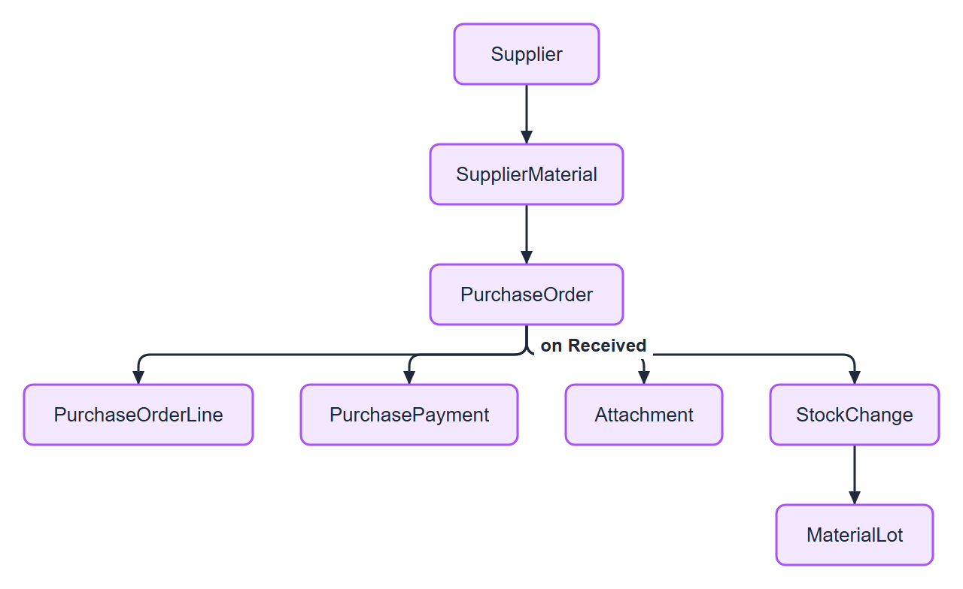
Figure 2. Chain of the new flows: Purchase
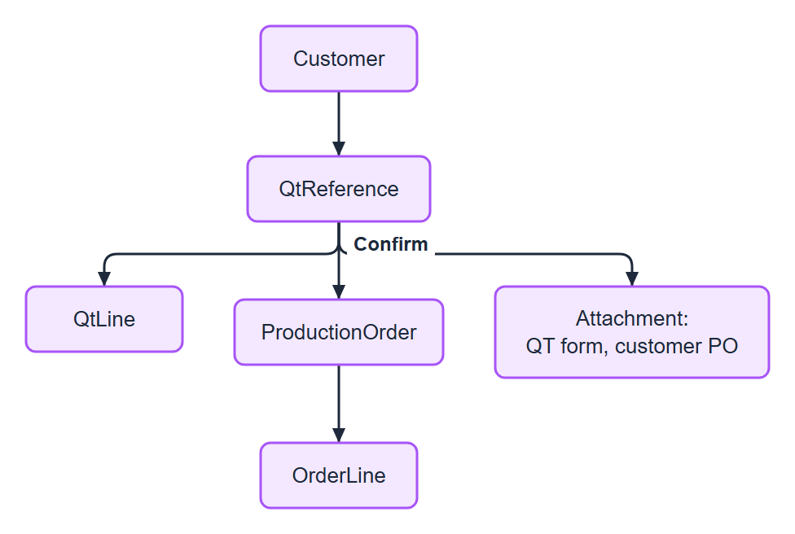
Figure 3. Chain of the new flows: Sale

